Theatre Booking
Project
George Cooke
2025

Index:
Aims & Objectives Page 3
Design Page 8
Design Overview Page 8
Inputs & Outputs Page 8
Code & Code Layout Page 9
Functionality Page 9
File Structure Page 15
The Code Page 16
Development Testing Page 17
Development Setbacks Page 17
Command-Line Tests Page 17
GUI Tests Page 20
Conclusion & Evaluation Page 25
Overview Page 25
What I’ve Learnt Page 26
Going Back to the Objectives Page 27
Potential Improvements Page 29
Opinions Page 30

Similar Programs & Inspiration
There are a multitude of different booking apps used around the world for all different purposes. Some are to book tickets to films, other for music festivals, some for sports, and some for aircraft seats. Going into this project the correlation that immediately jumped out to me was with booking tickets to the cinema. With the presence of assigned seating on a regular layout with showings that may not have predictable or consistent showing dates.
The programs I aim to take inspiration from are the Cineworld and Everyman cinemas. These are two good examples of seating booking systems that I have experience using and the layouts of these tools have been well tested and refined over the years that they have been in use.
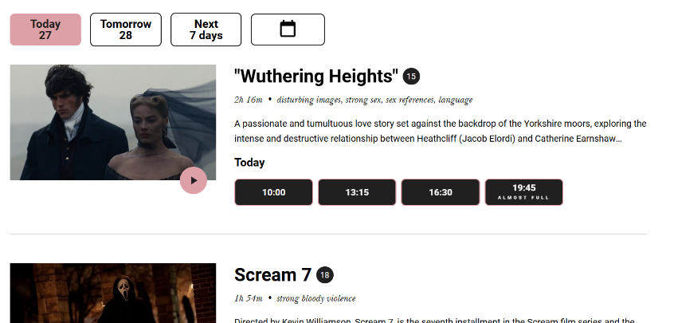
The image to the right is a screenshot of the Everyman website displaying the different films available. I like the possibility to go straight in to book specific dates and times for the films and will likely incorporate this as a target for my own program. Other than that, I like the presence of a description which is something I will copy for my own program. I will also take from this the horizontal line separating the different films. I believe that this will lead to a less cluttered appearance compared to my previous program with many boxes with rounded corners.
From the above page, a person can click on the title and go into further information and date/time selection. My program will assume that all showings are at the same time and there is a maximum of one showing per day per performance but there can be multiple performances at once in different rooms (it could be a stretch target to extend this to having separate time slots). I will likely replace this page with a custom one of my own design with just a number of simple buttons each with the date that they represent.

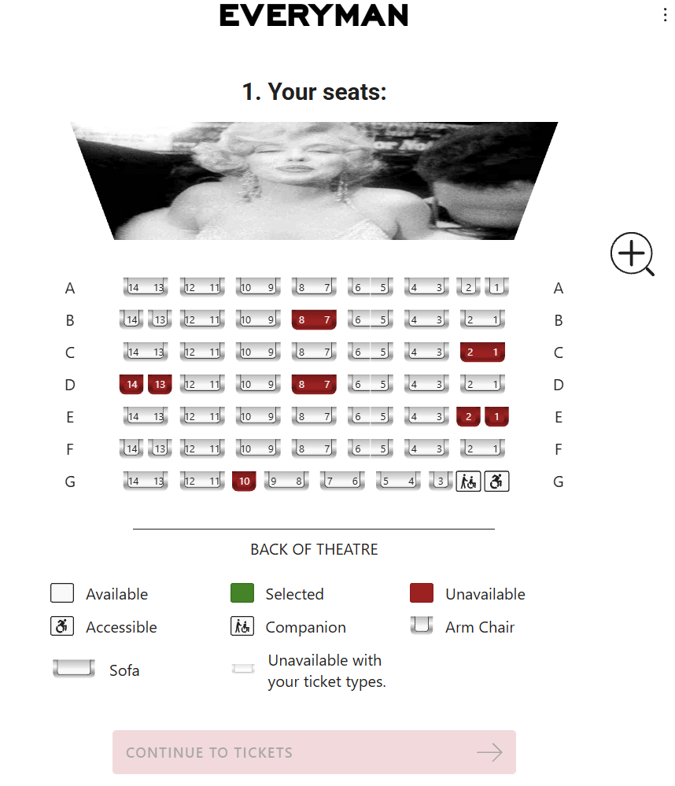
Having selected a date and time in the Everyman website, a user is sent to the seat selection page pictured to the right. I will copy from this the presence of a colour coded seat map and the key. With the Everyman website, there is a lot of white space to the right of this. I will likely replace this in my own section with a way of selecting which kinds of people will be attending (as the brief dictates that children and the elderly have tickets at half price).
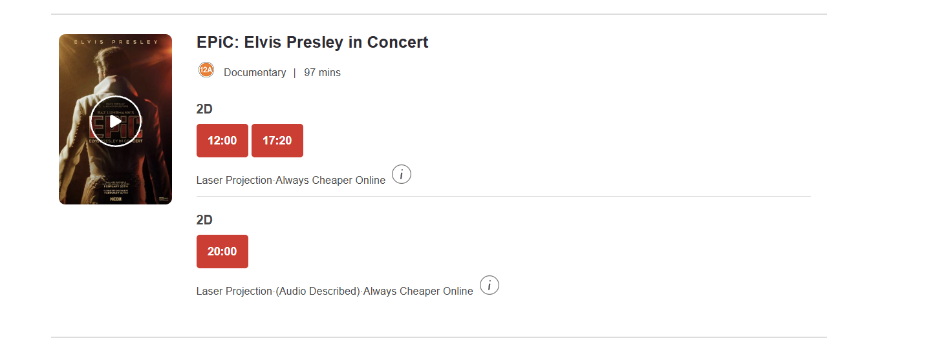
Cineworld has a very similar way of displaying what films are on (pictured right under Everyman). Again, I will draw inspiration from this with the vertical lines. One thing that Cineworld lacks compared to the Everyman is the description of each film on this page with a user having to go into the furtehr details of the film to see. I personally prefer Everyman’s approach and will be incorporating it into my design. This difference could be as a reuslt of Everyman’s propensity to show more indie and unknown films with the cinema itself being the event rather than the film. This means that they have to give a little more information about the films as people may not have heard of them whereas people would go to Cineworld with the intention of watching a specific film that they have already picked out.
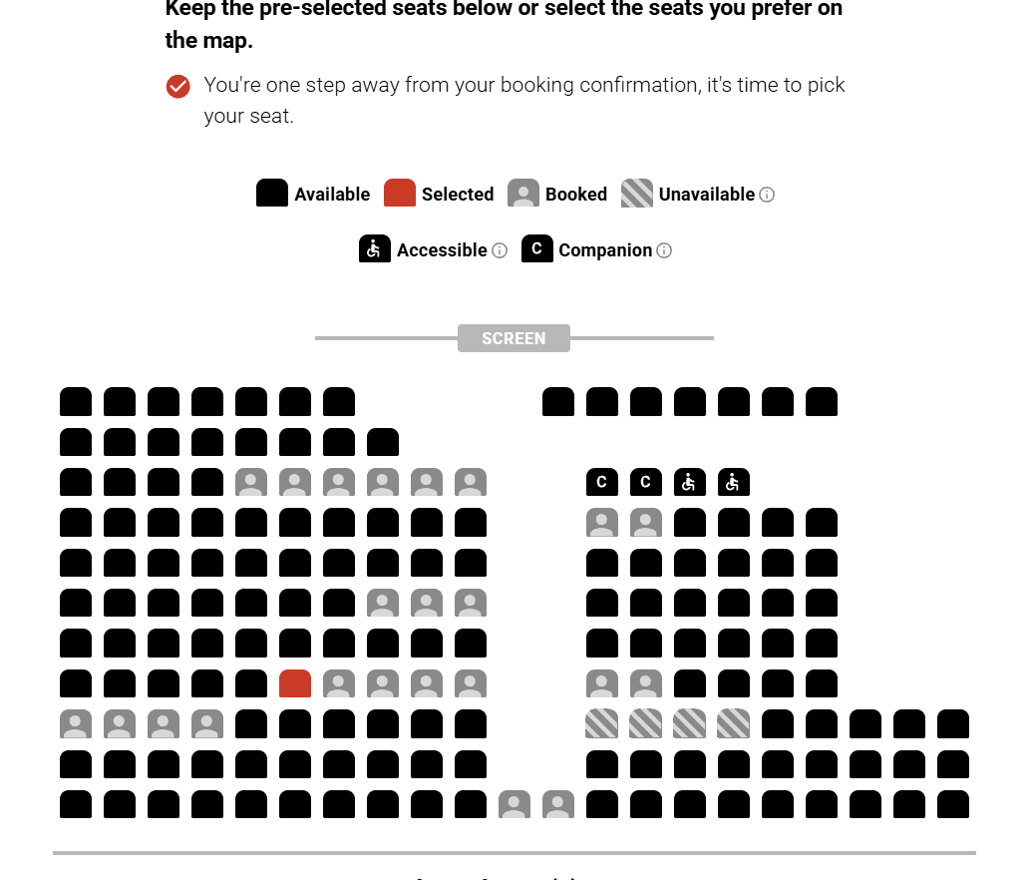
Cineworld makes a user select the number of seats that they want before going to the page for selecting seast (prictured right). I believe this is clunky and convelouted in a way that I do not want to incorporate into my own design. It also mean that in selection a user has to go through a complicated process of queueing up seats to unselect a seat they don’t want if they don’t want to go with the seats that were automatically assigned to them.
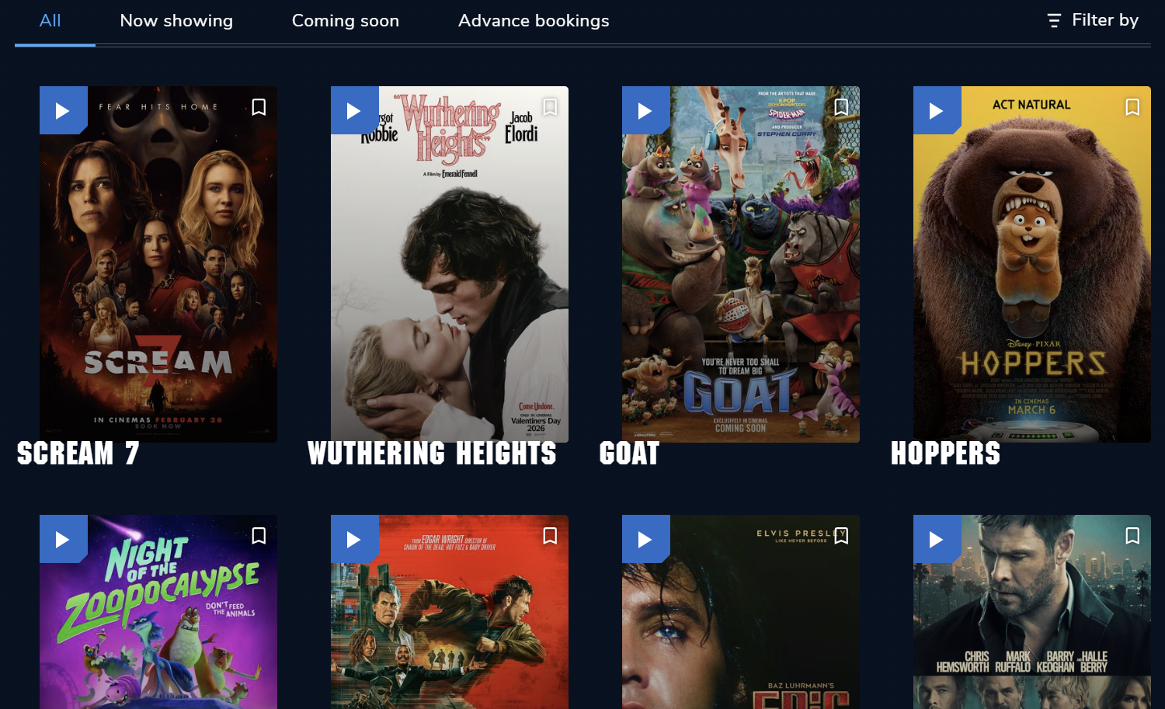
My third case study is the Odeon. It’s film selection page is pictured right. While I like the overall layout of this design as it is incredibly pleasing to the eye, it does have some issues that mean I don’t think I will be incorporating it into my own designs. For starters, it took an incredibly long time to load with all of the images. While it is entirely possible that this was because of a momentary issue with my internet, it cannot be discounted. Furthermore, I do not like the lack of the descriptions. I feel that in a school environment detailing the contents of lectures issued by guest speakers and things that people won’t have heard of, this could be counterproductive. This would be because people may not recognise the faces of the speakers or performers and as a result may not be inclined to click on the thumbnails for further information.
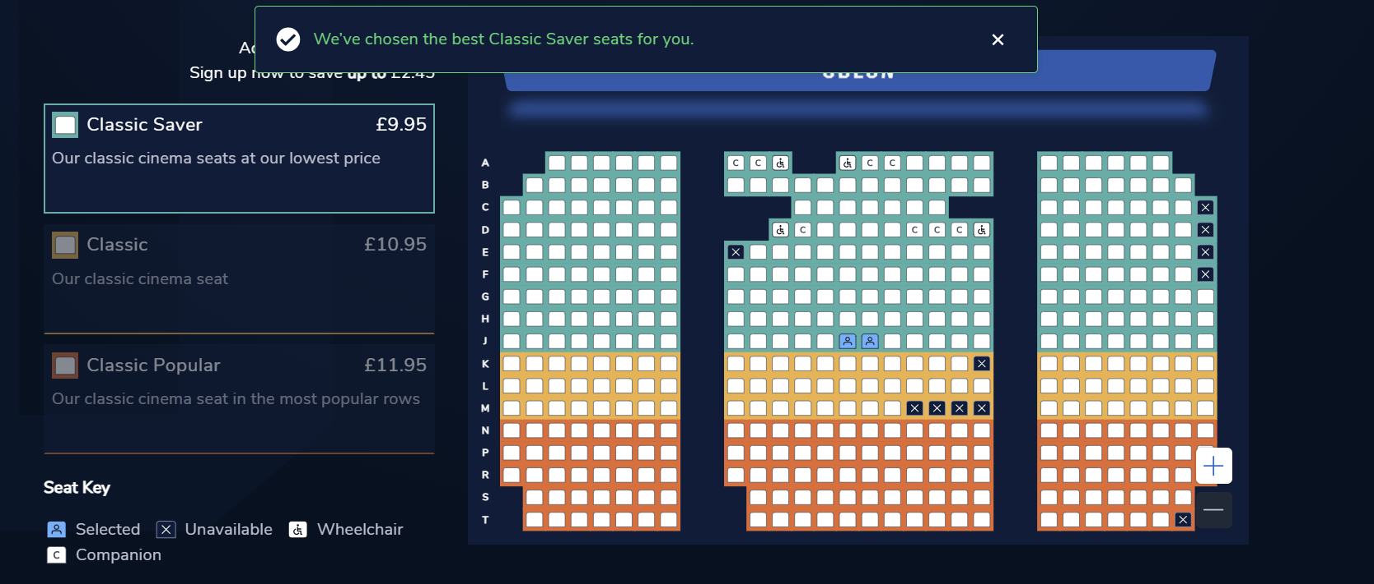
The seat booking page for the Odeon is now pictured right. I continue to like their dark theme but don’t think it would be appropriate for an academic website that would probably try to take itself a little more seriously. One thing that stands out from this platform as opposed to theothers is the presence of classed seating. This is a great idea but, again, I don’t think it would be approprate for a college website. One thing that is good is that it automatically selects what it things would be the “best seats” when you selct a class. This could be incorporated into a stretch target quite easily and I belive it could be most helpful.
Ultimately, all platforms have strong foundations and have been built on years of experience that I can draw inspiration from. I personally prefer the way that the Everyman uses and will be using manyof their design principals in my own work. That being said, the differences are very minor. This will mean that users will be used to a certain way of doing things. If I stick to this template, I be able to leave minimal instructions to users and I will be able to inherrit their experience with other similar platforms.

Stakeholders
Performers:
Performers are the people on the stage that will be performing the pieces on the stage. They could be actors, dancers, comedians, guest speakers or any number of people with different needs. While they will not interact directly with the booking system, they will be impacted by the functionalities it has.
It is possible that they will need special accommodations made with seats being closed off. That could be for their families, to give them adequate space to move, or because they may have special movement needs like being in a wheelchair.
As such, it will be important for seats to be blocked off for these purposes by admin staff so that the general public cannot buy specific seats.

Admin Staff:
Admin staff are the people who will be interacting with the management side of the program. They will have to be able to:
- Add new events,
- Block of seats for specific events,
- Add times for events,
- View and edit user types (standard, admin, special guest),
- Search for specific users,
- View which users are attending each showing,
- See how many seats are left at each showing,
- See how much revenue each showing it bringing in,
It could also be helpful for admin staff to be able to search for specific users within showings for the validation of tickets as well as book people in on their own system.
Admin staff may want to check tickets at the door by viewing the printout copy and comparing the name to the people attending. While the names will be sorted alphabetically by surname, it could be helpful to have search functionality. That being said, it is not necessary as they will be able to go through the names by alphabetical order. Furthermore, many events do not check tickets against their platform and instead opt to take tickets as what they appear to be. As such, this will be added to the stretch targets.
It could also be helpful to admin staff to be able to book tickets themselves for other people. This would be similar to staff at cinemas being able to buy you a ticket. This would not be possible with the current system. The main demographic that would find this helpful would be the elderly and those without technology access. The use of face-to-face systems like this is falling in the current climate so the use of something like this may not be what it would have been ten years ago. Furthermore, the elderly can be seen (from a business point of view) as a less valuable customer on account of their reduced ticket price. As such, it would not be economical to go to such great lengths to accommodate them. That being said, it would help to reduce the digital divide and build a more accommodating society. Ultimately, it would be beneficial to have the ability for admin staff to be able to book seats even if the functionality may not be used. As such, it will be added as a stretch target.

Visitors:
Visitors make up the majority of the user base for this program and their side of the systems will need the most attention as a result. Visitors should be assumed to be new to the platform and will therefore need more instructions and directions for what to do compared to admin staff that would have experience and training in the software.

They will have to be able to:
- Find events and showings that they want to watch,
- Select seats,
- Book tickets,
- Print tickets,
- View previous bookings,
While this is the most critical part of the system, it is also the most intuitive owing to the fact that everyone (myself included) has had extensive experience with them. This will mean that I can draw inspiration from other similar systems (see above) and draw on users’ knowledge on how to use them to reduce the need for instruction.

Disabled Visitors:
While the disabled community makes up a small percentage of the British population (approximately 4.9% of the British population have blue badges), Collyer’s is a large institution and it would be reasonable to assume that it has a number of students and carers with disabilities that would require special allowances. There is little that the system itself would need to do to accommodate for these people as the bulk of that responsibility falls on the event organisers.
Most modern browsers natively support accessibility features such as high contrast colours and text to speech with minimal input from developers which removes most of the workload from my end. Even then, I will have to ensure that elements are ordered and named sensibly to ensure that these features still work.
It could also be helpful to include a phone number on the receipt page for contact if a member of the party has a disability that may require special allowances to be made. This will ensure that they are adequately provided for and offloads liability from the software house to the college.

Limitations of the Current System
The brief did not mention any previous system. As such, I am led to believe it was simple pen and paper over the phone or in person.
This would have been cumbersome and prone to error. It would require a member of staff to constantly be present at the phone to take bookings. Furthermore, their handwriting would have to be legible enough for people to check if people have bought tickets. It may also not be organised in a sensible way leading to difficulty searching for names on entrance. Finally, it would be prone to error as humans make mistakes. This could be in double booking seats, putting people down for the wrong event or time, or miscalculating how many seats are still available.
Overall, this assumption of the current system demonstrates a great need for innovation to bring it forward to the 21st century and ensure that operations run smoothly.

Aims & Objectives
Threshold:
- Users can view events, times and book specific seats for them,
- Users can download a pdf version of the ticket,
- Admin staff can add events and showings (dates) for events,
- Admin can view all users and upgrade them to admin or special guest status,

Target:
- Show dates on overview of all events to book,
- Allow performances to be edited after adding to the database,
- Allow visitor users to edit their profile information (including password),
- Make use of the logging module,
- Program some automated tests that can be used to check code,

Stretch:
- Have separate timeslots for the day,
- Search users coming to specific showings,
- Admin can book seats,
- Admin can print tickets,
- Automatically select “best seats”,
- Use cookies for login details,

Full code and README can be viewed/downloaded from my GitHub.
Username: GeorgeCooke8809

Design
Abstraction
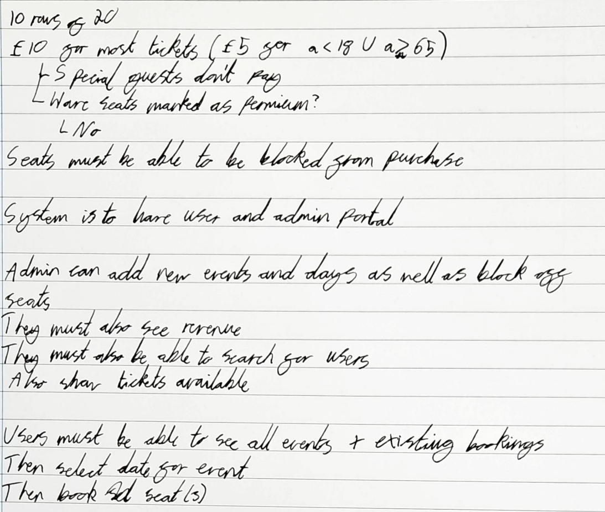
I like to complete the process of abstraction on paper by hand, my paper abstraction of the brief is attached below.

Overview
I will be making use of Flask for my application. This is both because it is more realistic to what a client would want with it enabling users to book online from anywhere but also because I think it is the best option for me. I am inexperienced with PyQt and would rather keep my distance from it. I would be open to using tkinter or custom tkinter but I believe that there would be great performance issues on the booking page as it has to render 200 different seats. As a result, I believe that a web page is the most appropriate choice.
My tool will have two separate portals. One for users and one for admins. Admins will have to be able to:
- Add new events,
- Block of seats for specific events,
- Add times for events,
- View and edit user types (standard, admin, special guest),
- Search for specific users,
- View which users are attending each showing,
- See how many seats are left at each showing,
- See how much revenue each showing it bringing in,
Users will have to be able to:
- Find events and showings that they want to watch,
- Select seats,
- Book tickets,
- Print tickets,
- View previous bookings,

I will also have to make sure there is a GUI for the selection of specific seats. This will ensure that users know where they will be sitting and can coordinate with other parties. One way I could design this within my code is with a for loop. This would save me the effort of writing out each different item by hand and would make my code more efficient. This could be done in the JavaScript or python embedded in the html.

UI
For my colour scheme I will take inspiration from the Collyer’s website and take the colour of their banner for my own. This will ensure that I incorporate the Collyer’s colour scheme. This will then leave my colour scheme as is shown below:

I elected to make my UI designs in Canva prior to designing any databases or programming any functionality. This is because it is the thing that I am most used to interacting with and I will thus be better equipped to visualise what a user would expect through this medium. I will then go on to use this as a tool to help me make flow charts and diagrams explaining all of the different subroutines I will need to make.
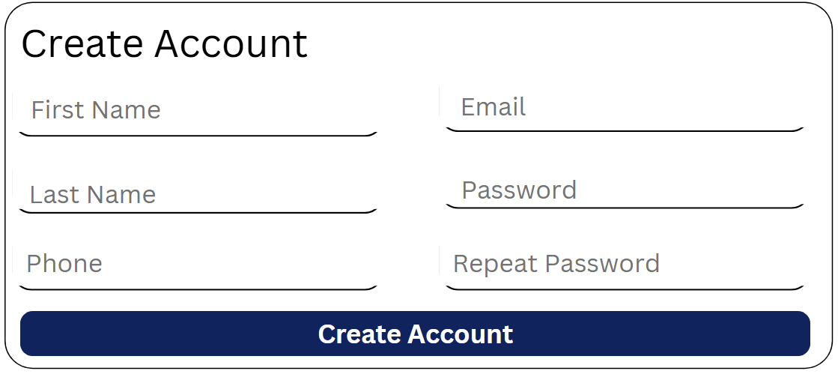
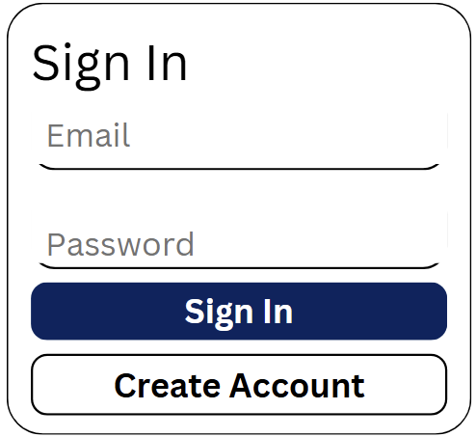
My first designs are for the login and create account page. This will be the index page that a user is sent to first (pictured right). My designs for the car park website were quite bubbly and over simplistic. I would like to maintain the modern aesthetic in this project without going to the bubbly look that makes it look excessively simple. I hope that these designs will help me adhere to this design ideology.
Note the use of “repeat password” in the create account section. This will form part of my validation so as to ensure users have typed the passwordd they intended to type. I will likely try to find a way and have the dots obscurring passwords in the sign in page. This is largely superficial as data transmitted will not be encrypted and my database will not be hashed but I hope it at least resembles security.
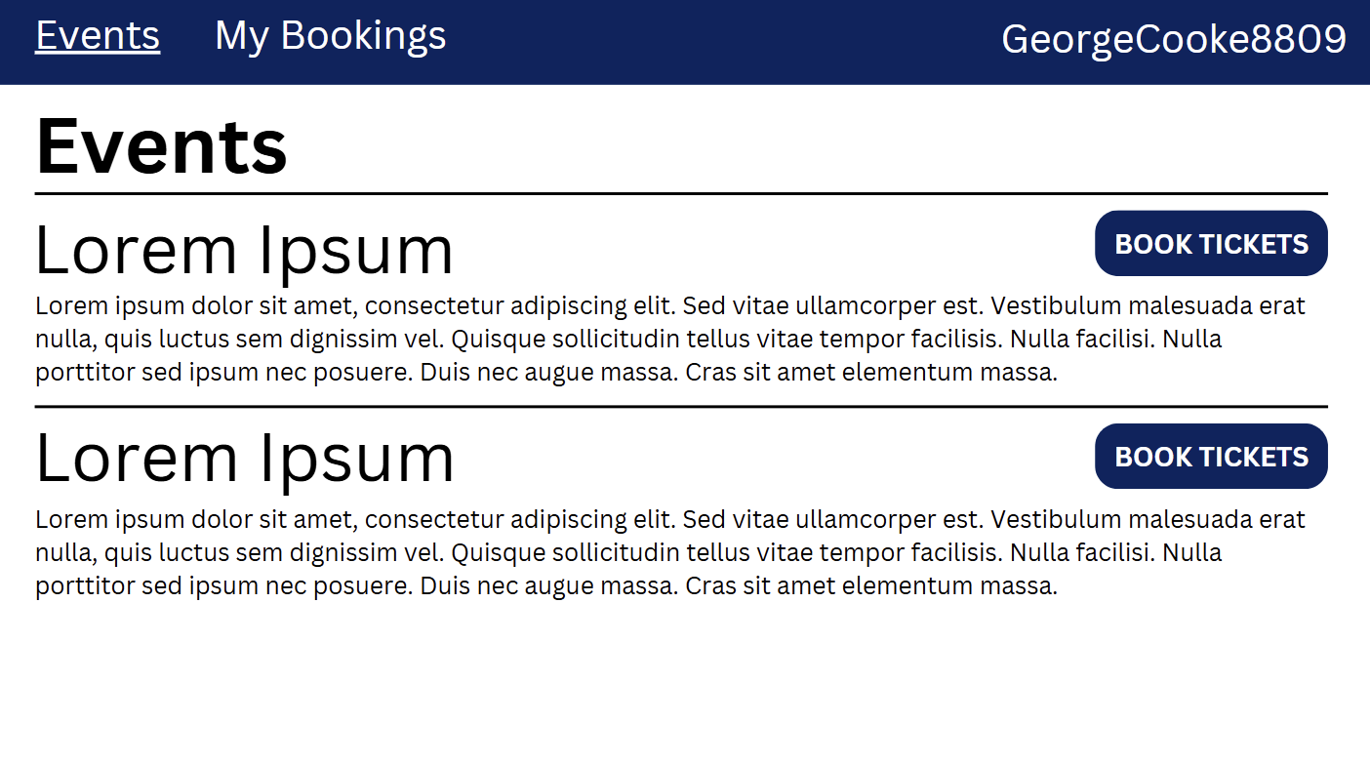
My next page of designs is for my main user dashboard page. This is where a visitor will be able to see all of the events that are being shown and a brief description of them. The book tickets button will take them to the next design.
The navigation bar at the top of the pictured page is the same across all visitor pages. The events button will take them to this page from any page they are at, the “my bookings” button will take them to a list of all their bookings (shown later) and their username in the top right will return them to the index page for log in if pressed.
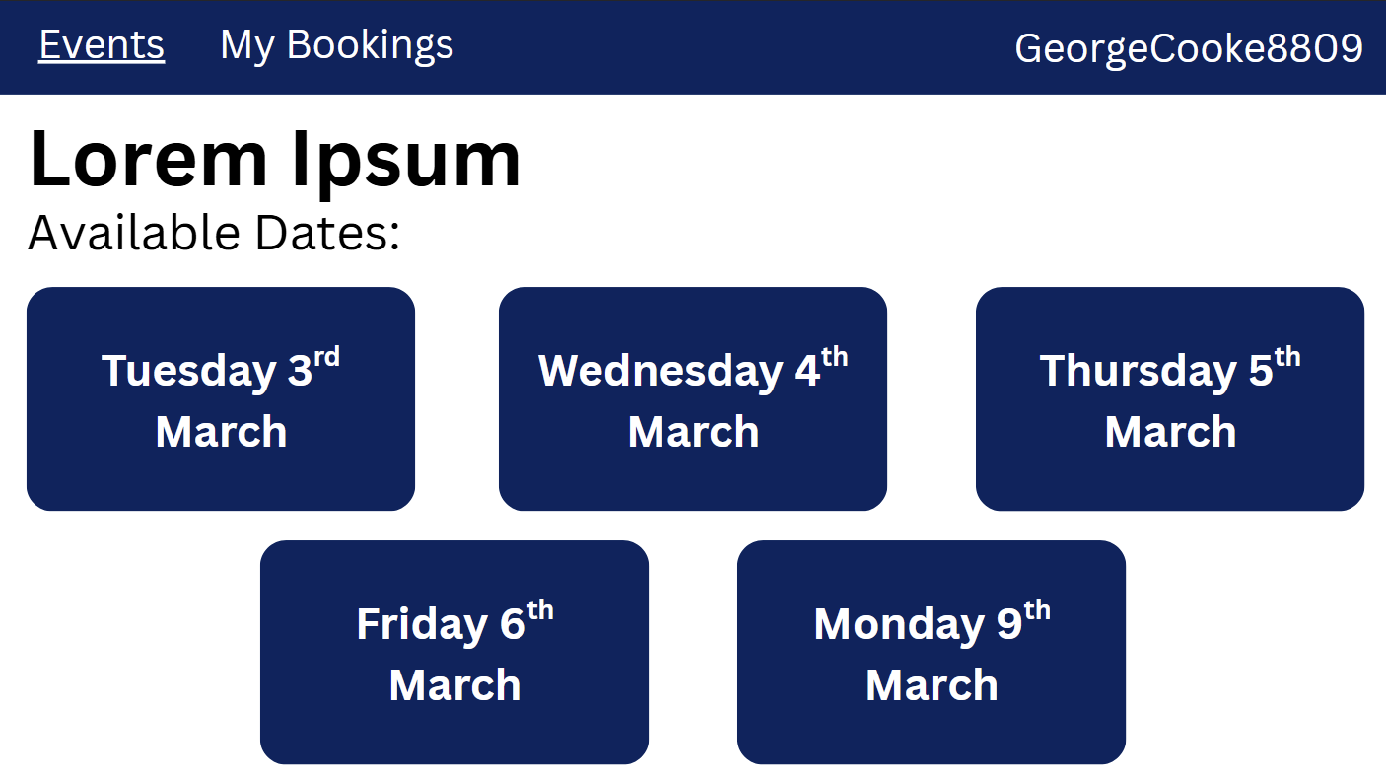
Having pressed the book tickets button on the previous page, they will be taken to the page shown to the right. This will contain a dynamic list of all the events that are not fully booked and are in the future (or present day). The dates on which events will take place can be set by the administrator.
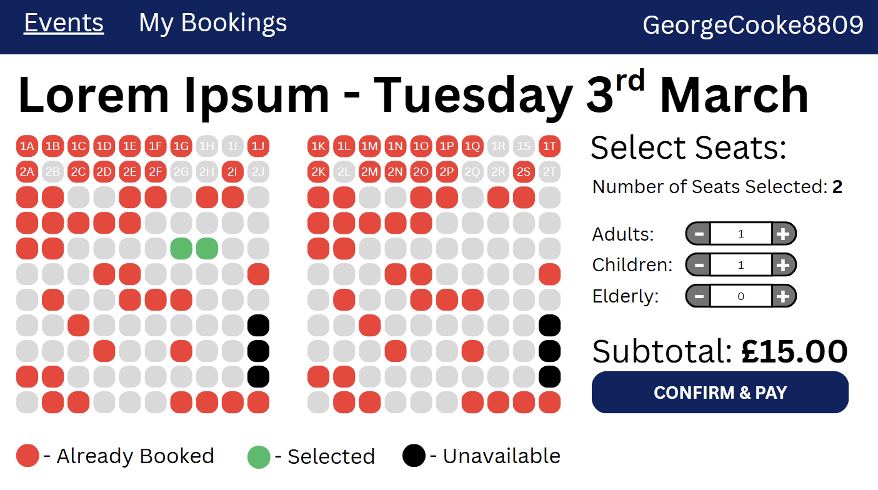
Following on from the page above, the user will be taken to the page shown to the right. This will show a seating map of all the available seatss which will be colour coded. On the right hand side of the screen, they will be able to select the number of people of each category that are in the party. The price will use JavaScript to refrence a custom Flask API that will return the price with the provided criteria (it will also take user ID so as to check if the user is a special guest); this will be refreshed whenever the types of people in the party is refreshed. If they attempt to confim and pay with the number of seats selected and the people in the party being in disagreement, it will flash a message to the bottom right of the screen and not allow them to proceed until they are in agreement.
In this graphic, on the top two rows of seast are numbered. In the final product, all seast will be numbered.
I may add a graphic showing where the stage is located to this page if space is available.
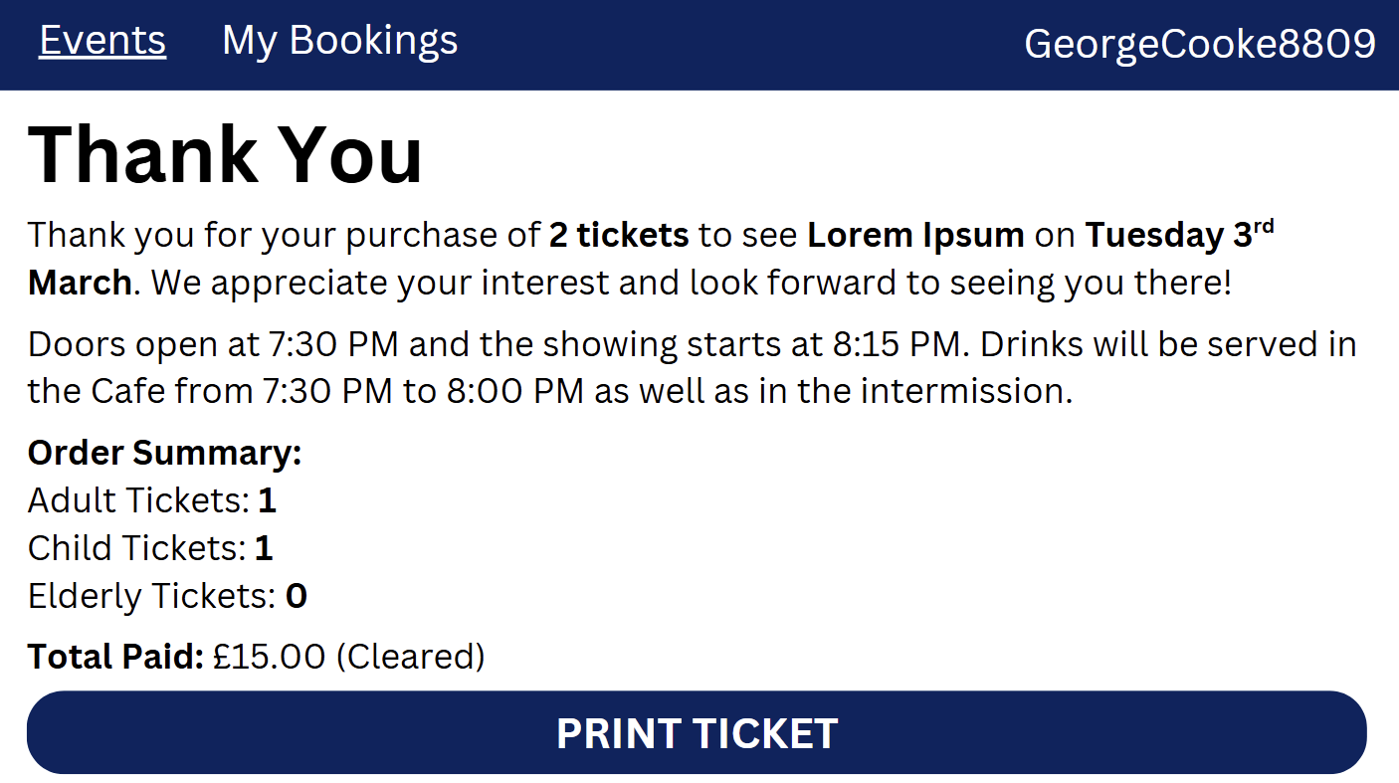
The page after this will be the recipt page thanking the user for their booking. This will have a brief overview of what they bought and a thanking message along with arbitary information about when the doors will open (this information will be the same for all events). It will also giove users an opportunity to print their ticket then which will download a PDF copy of the following page.
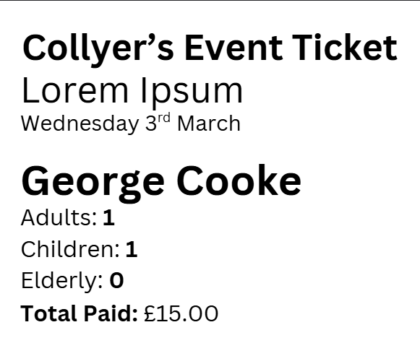
The image shown to the right is a copy of what a ticket/reciept will look like. It is not exceptionally complex but nor does it have to be. It is not designed to be scanned by administrators but they will instead have to either take it at its face value or look the user up in the relevent event bookings list.
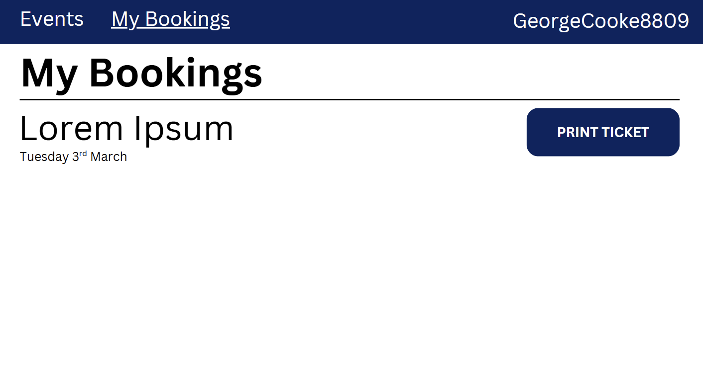
Having made a booking, a user will then be able to go to the “My Bookings” page to view all of their active bookings. This will show a list of all of their present and future bookings with the title of the performance, the date of the event they are booked on to and an option to print the reciept/ticket again should they have missed the opportunity the previous time around.
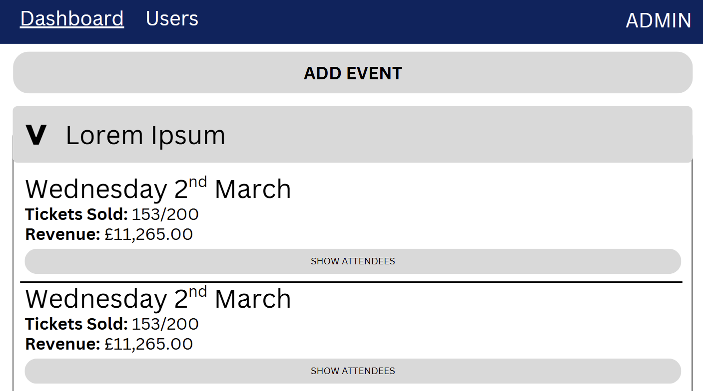
Moving on from the visitor portal, we move into the admin protal. The image shown to the right shows the main admin dashboard. This is where they will be able to:
- View all performances,
- View all showings of performances,
- Add new evetns,
- Add new showings,
- View who is attending each showing,
To prevent clutter, performances will initially be shown collapsed. This will hide any information about space, tickets sold, and revenue. Upon expanding a performance, the admin user will be met with an overview of each showing. Still collapsed will be the information about specific visitors for each showing. This can be expanded by pressing the “Show Atendees” button. When expanded, attendees for the event will be shown ordered by surname in alphabetical order.
Similarly to the user portal, the admin portal has the same naviagtion bar at the top of all windows. This shows the main tabs (“Dashboard”, and “Users”) as well as a button showing they are logged in as an admin which will log them out if pressed.
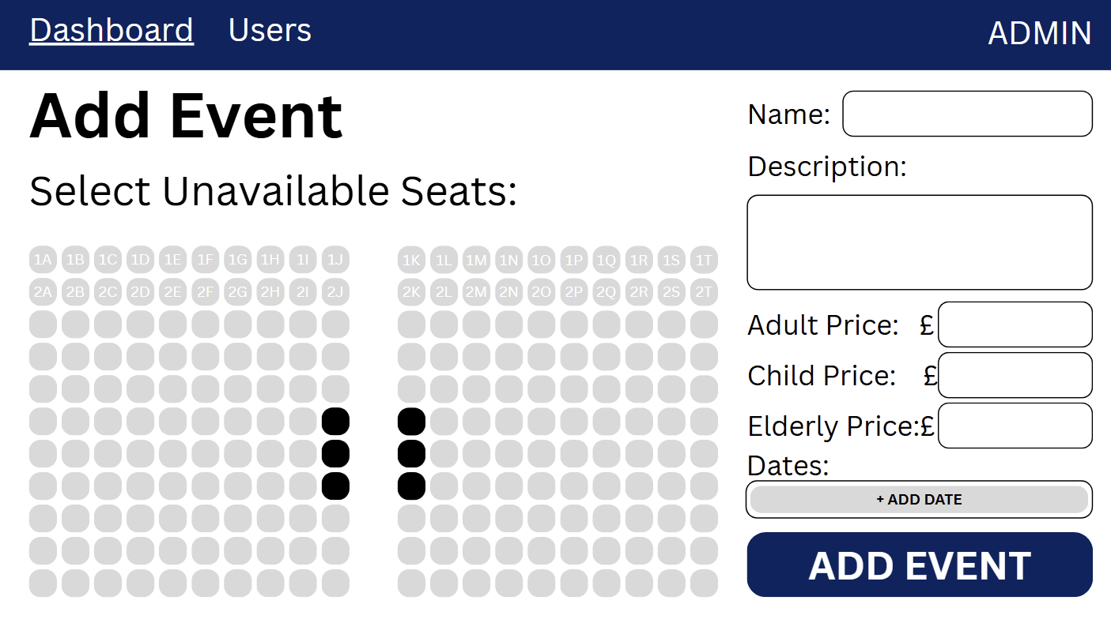
The image shown to the right it the page that an admin user will use to add a new event. I will likely change the scaling of the panel to the right here so as to give more space to the dates and description fields.
The seat map to the left will initially show all seast as being available (grey) but a admin user will be able to click on each seat they want to exclude from booking. This will make it unavailable for booking. This could be done to reserve it for members of the performance or to enhance accessability of the stage. Similar to the bookings page, all seats will be numbered as they are on the top two rows.
The admin user can also set the name, description, and prices here. I will likely autofill the prices to the deafult £10 and £5 values that I was provided in the original brief. Adding a date will be the equivalent of adding a showing in the dashboard page and when the button is pressed it will open a date select page. The list of dates will then be added to the box. On overflow, a scroll bar will appear so as not to change the formatting of the page.
On this page, all fields will be mandatory. If a field is left balnk, an error message will be flashed and the admin user will not be allowed to proceed.
One limitation of this system is that is assumes that the same seats will be marked as unavailable for all showings of a performance. It also does not allow different prices for different showings.
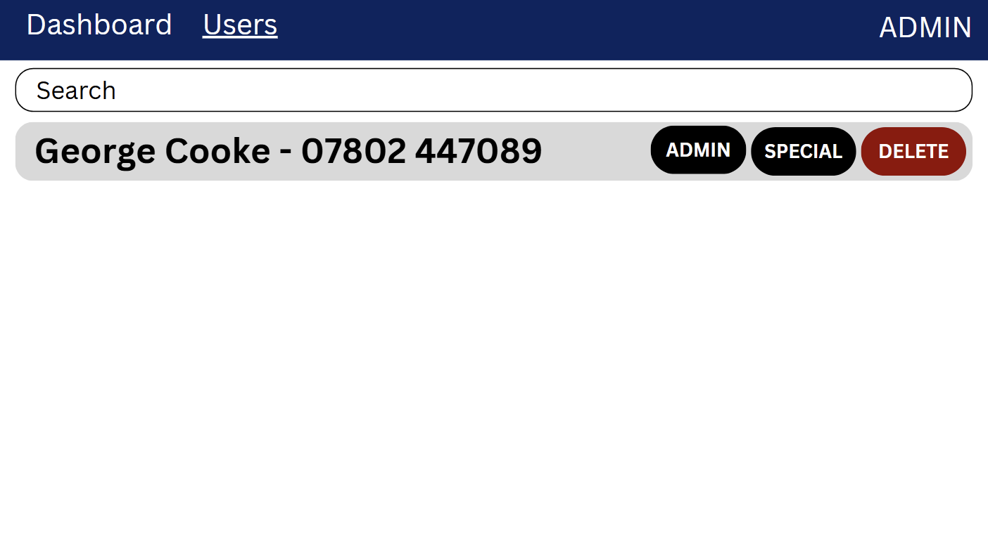
The image shown to the right is the last of the admin pages and will show a list of all users sorted in alphabetical order by surname. In this page, an admin user wil lhave the ability to view user names and phone numbers as well as mark useres as admin or special guests. Admin users will be sent to the admin portal when loggin in. Special guests are the people mentioned in the brief that get free tickets. Marking a user as one of these will ensure they receive free tickets. If a user is already marked as one of these, the relevent button will be changed to have the prefix “un-” e.g.: “UN-ADMIN”. A admin user also has the ability to delete a user from this page.

Systems
Database
Tables:
- Users(UserID, firstName, lastName, email, password, phone);
- Bookings(BookingID, ShowingID*, UserID*);
- BookingSeats(BookingSeatID*, BookingID*, SeatID*, type);
- Performances(PerformanceID, title, description, childPrice, adultPrice, elderlyPrice);
- PerformanceUnavailableSeats(PerformanceUnavailableSeatsID*, PerformanceID*, SeatID*);
- Seats(SeatID);
- Showings(ShowingID, PerformanceID*, Date);

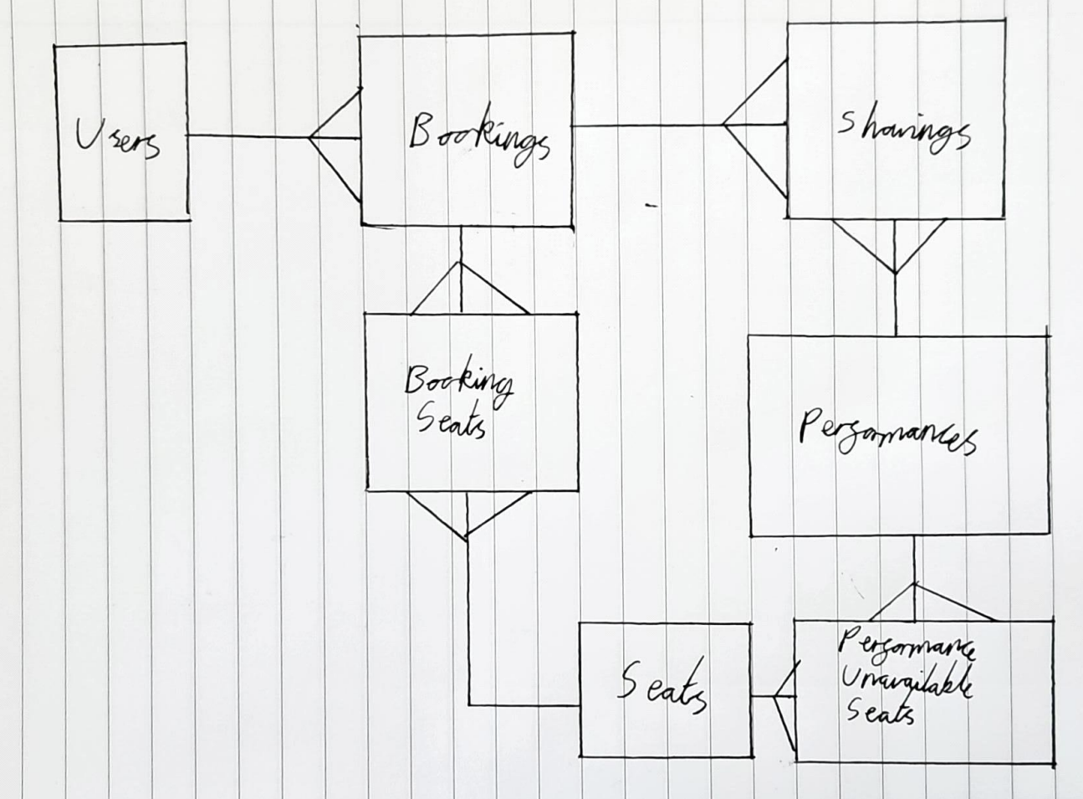
ERD:

Data Dictionary:
Users
Field Name | Field Data Type | Field Purpose | Field Validation | Example Data
UserID | INT | Unique identifier for every user | Automatically generated | 1  2  3
firstName | VARCHAR(30) | First name of user | Length check and suitable chars (alphabet, -, ‘) | George  Jamie  Olly
lastname | VARCHAR(30) | Surname of user | Length check and suitable chars (alphabet, -, ‘) | Cooke  Allsop  Kitson
email | VARCHAR(100) | Email of user for contact | Length check, has one at symbol followed by one full stop (at some point), check is not already in database | Georgecooke8809@gmail.com  25cookeg899@collyers.ac.uk  20gcooke@wardenparkradio.net
password | VARCHAR(50) | Password for logging in | Checked is the same as re-entry | Password123  Kvjwhvhhlau8y2lhg  avjbiluahgl
phone | VARCHAR(16) | Phone number for contact about bookings | Only contains numbers and spaces or hyphens, length check | 07802 447389  07801 749295  07744 456892
userType | VARCHAR( | The type of user (admin, special guest, visitor) | Is passed in by buttons so none needed | VISITOR  ADMIN  SPECIAL

Bookings
Field Name | Field Data Type | Field Purpose | Field Validation | Example Data
BookingID | INT | Unique identifier for every booking | Automatically generated | 1  2  3
ShowingID | INT | Unique identifier for every showing to show which show the booking is for | Automatically generated | 1  2  3
UserID | INT | Unique identifier for every user showing who booked the booking | Automatically generated | 1  2  3

Booking Seats
Field Name | Field Data Type | Field Purpose | Field Validation | Example Data
BookingSeatID | INT | Unique identifier for every booking seat | Automatically generated | 1  2  3
BookingID | INT | Unique identifier for every booking seat | Automatically generated | 1  2  3
SeatID | VARCHAR(3) | Unique identifier for every booking seat | Automatically generated | 1A  2B  5C
bookingType | VARCHAR(7) | The type of visitor using the seat | One of the three valid options | CHILD  ADULT  ELDERLY

Performances
Field Name | Field Data Type | Field Purpose | Field Validation | Example Data
PerformanceID | INT | Unique identifier for every performance | Automatically generated | 1  2  3
title | VARCHAR(100) | The title of the performance | Length check | Hamilton  Star Wars: Episode IV - A New Hope  Star Wars: Episode III - Revenge of The Sith
performanceDescription | VARCHAR(MAX) | The description of the performance | None | …
childPrice | DECIMAL(2) | The price for a child ticket | Two decimal places, >= 0 | 5.00  7.50  10.12
adultPrice | DECIMAL(2) | The price for an adult ticket | Two decimal places, >= 0 | 5.00  7.50  10.12
elderlyPrice | DECIMAL(2) | The price for an elderly ticket | Two decimal places, >= 0 | 5.00  7.50  10.12

Performance Unavailable Seats
Field Name | Field Data Type | Field Purpose | Field Validation | Example Data
PerformanceUnavailableSeatsID | INT | Unique identifier for every performance | Automatically generated | 1  2  3
PerformanceID | INT | Unique identifier for every performance | Automatically generated | 1  2  3
SeatID | VARCHAR(3) | Unique identifier for every unavailable seat | Automatically generated | 1A  2B  5C

Seats
Field Name | Field Data Type | Field Purpose | Field Validation | Example Data
SeatID | VARCHAR(3) | Unique identifier for every seat | Automatically generated | 1A  2B  5C

Showings
Field Name | Field Data Type | Field Purpose | Field Validation | Example Data
ShowingID | INT | Unique identifier for every showing | Automatically generated | 1  2  3
PerformanceID | INT | Unique identifier for every performance to show the performance the showing is for | Automatically generated | 1  2  3
showingDate | DATE | The date the showing is on | Passed in by a date select that provides a consistent format, range check (on or after current date when added) | 03/03/2026  01/04/2026  07/05/2026

Decomposition & Algorithms
- Log In
  - Log In
    - Check log in details,
    - IF LOG IN DETAILS CORRECT: send user to relevant portal,
    - IF LOG IN DETAILS INCORRECT: flash error message,
  - Create Account
    - Take in user details,
    - Validate user details,
- First name and last name are valid length and contains only letters,
- Email is valid length, has @ symbol followed by “.” (at some point), and not already in database,
- Phone has only numbers,
- Passwords are the same,
    - IF CREATE USER DETAILS VALID: pass into database,
    - IF CREATE USER DETAILS INVALID: flash error message

- User Portal
  - View available performances,
    - Get list of all performances with space available and events after or on current date,
    - Show list of all performances,
    - Select date for event,
      - Get all dates for performance where date is after or on current and not full,
      - Show all valid dates for performance,
      - Book seats,
        - Select seats,
        - Select party composition
        - Get price,
        - Check party size agrees with seat selection
        - IF PARTY SIZE DISAGREES: flash error message and prevent proceed
        - IF PARTY SIZE AGREES: Submit to database
  - View booked performances,
    - Get all booked performances after and including current date,
    - Show all valid bookings,
  - Print ticket for performance – inside booked performances page,
    - Generate PDF,
    - Download PDF,
  - Log out,
    - Redirect to index page,

- Admin Portal
  - Dashboard page
    - Add event,
      - Get data and add to custom internal API
        - Select unavailable seats,
        - Set title,
        - Set description,
        - Set prices,
          - Child,
          - Adult,
          - Elderly,
        - Set dates,
      - Add event,
        - Create new event,
        - Add showings to event,
    - View event,
      - Display showings,
        - Get showings (ordered by ascending date)
        - Display basic information,
          - Seats available,
          - Revenue,
          - Date,
        - Display attendees,
      - Add new showing,
        - Get date,
        - Add showing,
  - Users page
    - Get all users
      - Get a list of all users,
      - Return and display the list of all users
        - Get list of users,
        - Determine if admin or guest already
        - Display with relevant buttons
      - Toggle admin of user,
        - Set type to user or special as required,
      - Toggle special of user,
        - Set type to user or special as required,
      - Delete user,
        - Delete user,
  - Log out
    - Redirect to index page

Inputs & Outputs:
Input | Location | Processing | Output
Email text entry | Sign in page (1st row) | - | -
Password text entry | Sign in page (2nd row) | - | -
Sign in button | Sign in page (3rd row) | Validates log in information and redirects to relevant dashboard | Redirects to relevant dashboard
Create account button | Sign in page (4th row) | Redirect to create new account page | Redirect to create new account page
First name text entry | Create account page (1st row, 1st column) | - | -
Last name text entry | Create account page (2nd row, 1st column) | - | -
Phone text entry | Create account page (3rd row, 1st column) | - | -
Email text entry | Create account page (1st row, 2nd column) | - | -
Password text entry | Create account page (2nd row, 2nd column) | - | -
Repeat password text entry | Create account page (3rd row, 2nd column) | - | -
Create account button | Create account page (bottom row) | Checks email is not in database, checks passwords are the same, passes data into database, redirects to sign in page | Redirects to sign in page
Events button | Top left of every visitor page | Redirects to events page | Redirects to events page
My bookings button | Top left (ish) of every visitor page | Redirects to my bookings page | Redirects to my bookings page
Log out button (displayed as full name) | Top right of every visitor page | Redirects to my bookings page | Redirects to my bookings page
Book tickets button | To the left of every performance in the main visitors events page | Redirects to date (showing) select for relevant performance | Redirects to date (showing) select for relevant performance
Date select button(s) | The buttons in the main body of the performance date selection page | Redirects to relevant booking page | Redirects to relevant booking page
Seat select buttons | The left column of the booking page | Toggles the colour of the button and toggle the relevant seat from a list of seats to be added to the booking | Toggles the colour of the seat
Number of adults seats number select | Right hand column, 1st row of booking page | - | -
Number of children seats number select | Right hand column, 2nd row of booking page | - | -
Number of elderly seats number select | Right hand column, 3rd row of booking page | - | -
Confirm & Pay button | Bottom of right column in booking page | Checks number of seats selected and seat type numbers agree, push to database and redirect to thank you page | Redirect to thank you page
Print ticket button | Thank you page | Create PDF ticket for relevant booking and send to user for download | PDF ticket downloaded
Print ticket button | My bookings page | Create PDF ticket for relevant booking and send to user for download | PDF ticket downloaded
Dashboard button | Top left of every admin page | Redirect to admin dashboard page | Redirect to admin dashboard page
Users button | Top left (ish) of every admin page | Redirect to admin users page | Redirect to admin users page
Logout button (displayed as admin) | Top right of every admin page | Redirect to sign in page | Redirect to sign in page
Expand event button | The arrow next to every event entry in the admin dashboard page | Expand selection | Expand selection
Show attendees | Under each showing of an event when the event is expanded | Expand selection | Expand to show people booked on to showing
Add showing date select | At the bottom of the expanded performance information | Adds new date to performance | Refreshes page and shows new showing
Seat buttons | Add event page for admin | Toggle colour of seat and toggle from array for later processing | Toggle colour of seat
Name text entry | 1st row of right column in add event page | - | -
Description text entry | 2nd row of right column in add event page | - | -
Adult price number entry (decimal) | 3rd row of right column in add event page | - | -
Child price number entry (decimal) | 4th row of right column in add event page | - | -
Elderly price number entry (decimal) | 5th row of right column in add event page | - | -
Add date date select | 6th row of right column in add event page | Adds date to list of dates and shows it in the scrollable frame | Shows the date in the list
Date button | In the 6th row of the right column in add event page | Clears the date from the list and hides it | Removes date from the list
Add event button | Bottom of the right column in add event page | Validates all the date entered and adds to database then redirects to admin dashboard | Redirects to admin dashboard
Admin button | Users page | Toggles if a user is an admin user | Refreshes the page
Special button | Users page | Toggles if a user is a special guest and refreshes the page | Refreshes the page
Delete button | Users page | Deletes a user and refreshes the page | Refreshes the page

Pseudocode:

Testing
Development Testing:
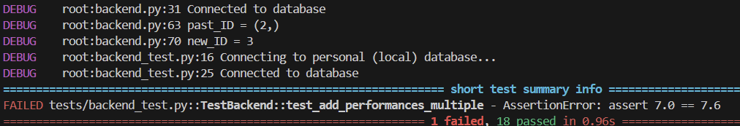
Error #1:
The error pictured to the right occurred when trying to add functionality to custom prices for performances. My error was in using the incorrect data type in setting up my database. I used DECIMAL(2) without providing a number of decimal places. This meant that values were automatically rounded to the nearest whole number. A similar issue occurred when trying to insert values for price with any more than 2 digits before the decimal point. Corrected by changing SQL table creation command to DECIMAL(7, 2)

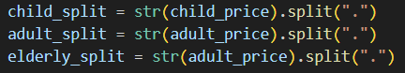
Error #2:
This was a simple error that came from me copy and pasting this code so as to save myself time. You can see in the screenshot that I forgot to change the str(adult_price) in the third line to elderly_price. This meant that it was not correctly validating the number of decimal places in the number which led to errors. Fortunately, this was caught during my unit testing.

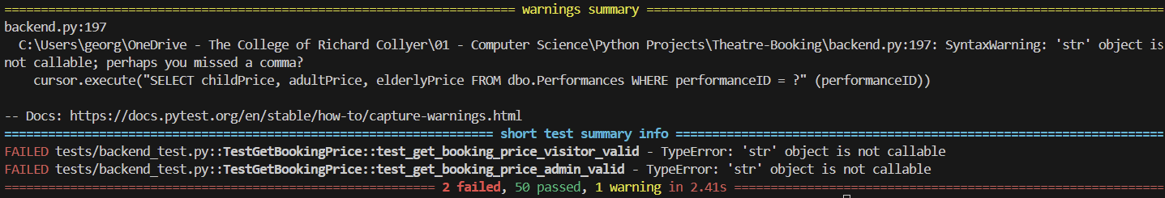
Error #3:
This error was another simple one. You can see in the warnings summary as well as the code screenshot below that I forgot to add the comma in my SQL statement where I insert the variables. It read (“SELECT childPrice, adultPrice, elderlyPrice FROM dbo.Performances WHERE performanceID = ?” (performanceID)) where it should have read (“SELECT childPrice, adultPrice, elderlyPrice FROM dbo.Performances WHERE performanceID = ?”, (performanceID)).

Error #4:
This is another simple error that stems from me using the incorrect data type in my declaration of tables. In my data dictionary, I declared seatID to be VARCHAR(3) but I unfortunately neglected to do this when actually making the table and defaulted to INT.

GUI Tests
Test No. | Purpose | Test | Inputs | Expected Outputs | Real Outputs | Pass/Fail | Potential Fix / Comment

Conclusion & Evaluation
Overview:

What I’ve Learnt:

Going Back to the Objectives:

Potential Improvements:

Opinions:

